**Hong Kong Institute of Vocational Education**

**Department of Information Technology**

**HD in Software Engineering**

**Project Proposal**

**Automated Data Collecting System for Environment Using UAVs and Smartphones**

|  |  |
| --- | --- |
| **Student Name** | **Student ID** |
| Wong Ming Yuen | 180275359 |
| Siu Chi Wang | 180042945 |
| Kwok Tsz Lung | 180047074 |
| Chau Yat Sum | 180478187 |

Table of contents

System Architecture 3

Requirements of the System 4

Functional Requirements 4

Transfer Real-time video 4

Control Directly 4

Take video and photo 4

Collect Environment Data 4

Display Collected Data 4

Keep Collected Data 4

Non-functional Requirements 4

Operational 4

Performance 4

Security 4

Cultural and political 4

Data Handling 4

Proposed Solution 5

Feasibility Analysis 5

Budget 5

Staffing & Responsibilities 6

Main deliverables 6

Problem to be solved

The system to be proposed will provide services on drone and smartphone users. It will allow users to collect data of the atmosphere, by different sensors, control a drone with smartphone by 4G connection and stream by live camera on the drone.

Background

Since the observatory cannot provide an accurate data for every region. The drone could help people to collect data accurately to decide equipment to be bring on that day. Also, there may be some special situation happened on the road e.g. Trees falls and blocked the road. Users could avoid walking those roads to save time of changing route.

# System Architecture

We prefer using Three-tiered architecture as our architecture design. It determines how the information system will be assigned to the hardware devices of the system.

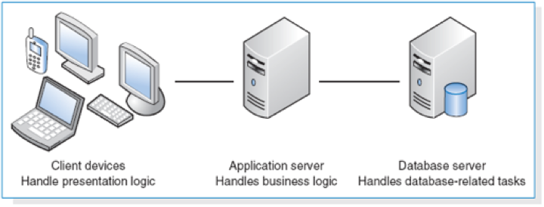

With Three-tiered architecture, you have the ability to utilize new technologies as they become available. This ensures your product is ready to adapt; ready for the future. You have actually look not only to today’s needs but into the future. Stay ahead of the game and maintain a competitive advantage.

# Requirements of the System

## Functional Requirements

### Transfer Real-time video

Users can watch the real-time video which the image is shot by UAV (Unmanned Aerial Vehicle) through the system. The max resolution of the video is 720p and the frames is 60 per second. Also, these can be adjusted by users.

### Control Directly

Users can control the drone directly via the part of phone application of the system. On the same time, the real-time video is available to users.

### Take video and photo

All flying process of the drone can be taken for a video. In addition, users can take a photo on arbitrary time.

### Collect Environment Data

On UAV, there are different type of sensors to collect the environment data including humidity, temperature, PM2.5 (suspension of fine particles), ultraviolet light, smoke, air pressure and noise.

### Display Collected Data

The system will display real-time data and previous record collected by the phone connected UAV. on the part of phone application of the system, the real-time data display on the other view out of the control view.

### Keep Collected Data

All collected data will be saved to server.

## Non-functional Requirements

### Operational

No special operational requirements are expected.

### Performance

As for prevent wasting operation, the processing speed of system should be monitored and kept at an acceptable level. The ideal response time should be within 2 seconds.

### Security

To protect personal information security risks. User logging in the system should be required to authenticate.

### Cultural and political

The using of the UAV must obey related law of the area.

# Data Handling

The collected data synchronize on UAV and the system. Also, users can upload the data to the server.

# Proposed Solution

Our UAVs are all made by us, so we can meet the requirement of cost effective.

# Feasibility Analysis

|  |
| --- |
| Technical Feasibility  -Risk regarding familiarity with new system is moderately low:   * The program is designed with user-friendly GUI so they may easily pick-up the new system.   -The risk of the project size is considered low:   * Our project team has enough manpower. * The project time frame is more than enough. |
| Economic Feasibility  -Benefits and Costs:   * Benefits:   + Intangible Benefits:     - Let one knows how the current situation of the environment is * Costs:   + Operational Costs:  ~Ingredients fee |
| Organizational Feasibility  - Looking in the organizational viewpoint, the project is considered with low risk.   * Our project team leader is an intelligent and a capable guy with great leadership. * Everyone in the team has agreed to make that product for the project. |

# Budget

|  |  |
| --- | --- |
| Design | |
| Controller | 1599 |
| Total | 1599 |

Staffing & Responsibilities

|  |  |  |
| --- | --- | --- |
| Leader, programmer | Leads the group, write a pc application | Wong Ming Yuen |
| Designer, programmer | Buy ingredients and design the product, write pc application | Siu Chi Wang |
| Programmer | Write database, write Android application | Kwok Tsz Lung |
| Programmer | Write Android application | Chau Yat Sum |

# Main deliverables

A UAV: that is made by us and include several sensors.

An android app: that is a controller of the UAV

A windows app: that is a monitor of the UAV